CPE 324-01: Advanced Logic Design Laboratory

Lab07

Computer Display Interface

Submitted by: Esther Shore

Date of Experiment(s): March 21, 2024 and March 26, 2024

Report Deadline: March 28, 2024

1. Introduction

The purpose of this lab is to develop a deeper understanding of computer display technology by designing logic to drive an SVGA display on the DE2-115 board. The task involves creating modules to generate synchronization signals, translate pixel addresses, and handle color intensities. Ultimately, the experiment aims to display a 256-color, 256x256 pixel image of the DE2-115 board on the SVGA screen, with the ability to resize and rotate the image based on user input from the DE2-115 board's buttons.

1. Experiment Description

Part 1:

In Assignment Part 1, we will complete the svga_sync module, which is crucial for generating the timing signals required to drive the SVGA display. We'll delve into VGA timing specifications, including vertical and horizontal refresh cycles, and implement timing functionality to produce the necessary synchronization pulses. Our task involves utilizing our knowledge of Verilog coding and digital logic design principles to develop the module, ensuring accurate timing generation for proper pixel scanning and display on the SVGA monitor. Successful completion of this part will result in a functional synchronization module capable of driving the display in accordance with VGA standards.

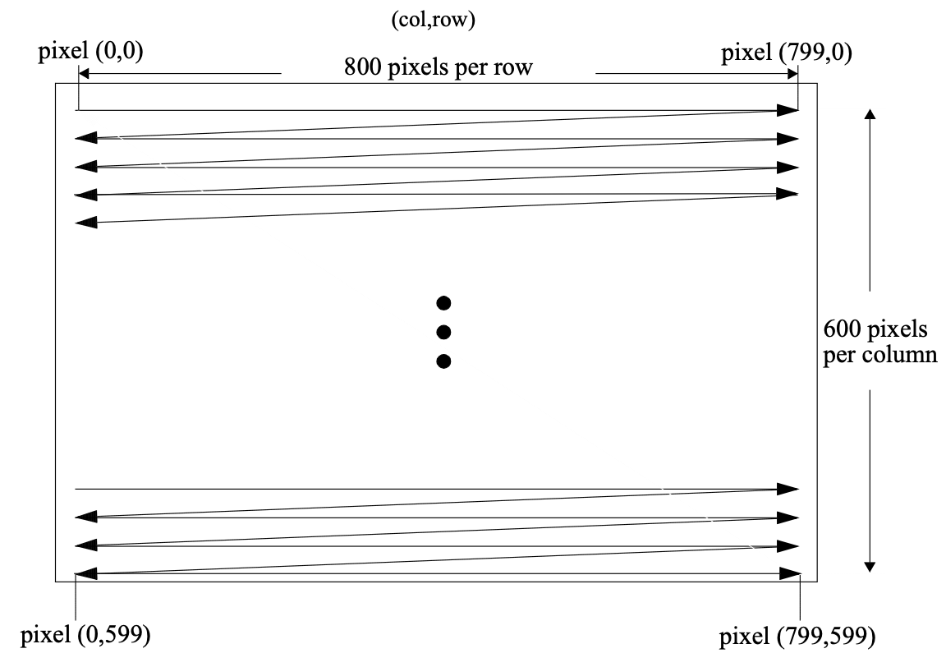

**Figure 1.** SVGA Pixel Layout and Tracing for 800 x 600 Resolution

In order to accomplish this task, we had to understand how the SVGA monitor functions. The pixel configuration can be seen in Figure 1, where the pixels are illuminated through the raster scan process from left to right and top to bottom at a refresh rate faster than the human eye can observe. This process involves two synchronization signals: the vertical sync signal and the horizontal sync signal. These refresh cycles are shown in Figure 2 and Figure 3. The vertical sync signal tells the monitor that a new frame should be displayed while the horizontal sync signal informs the monitor that a new row is to be displayed.

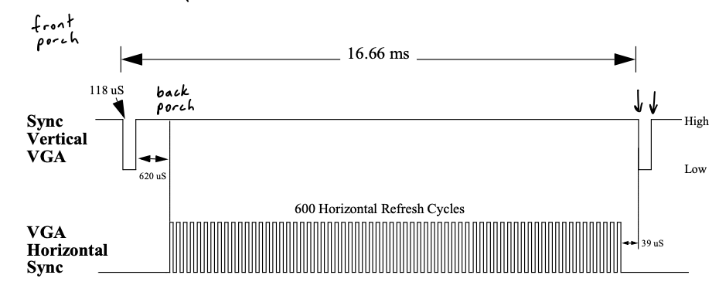

**Figure 2.** VGA Vertical Refresh Cycle

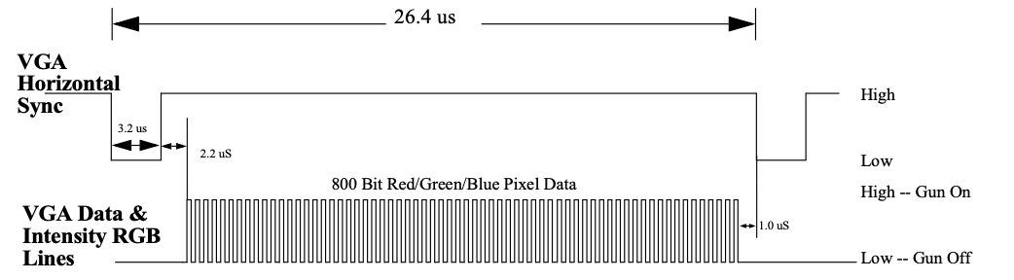

**Figure 3.** SVGA Horizontal Refresh Cycle

The overall top-level design also had to be understood in order to comprehend how the svga_sync module was integrated into the system and the functionality of the other modules. This is displayed in Figure 4.

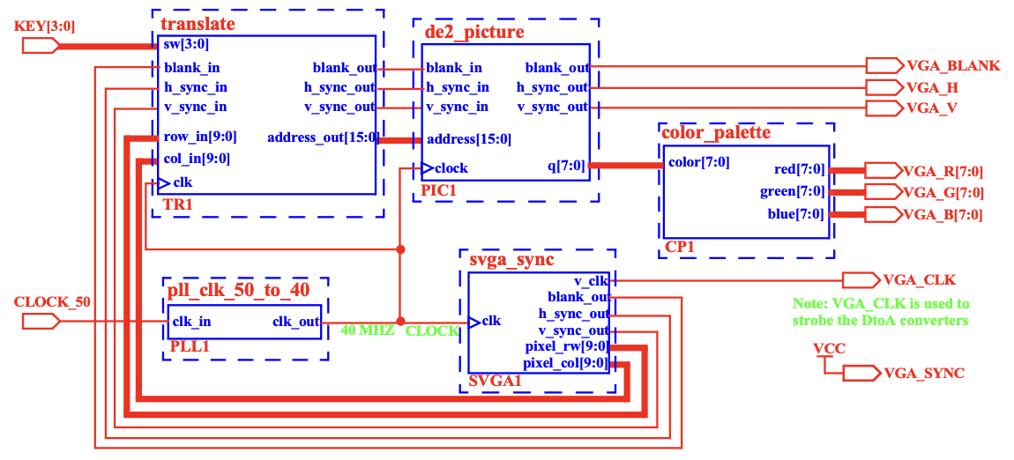

**Figure 4.** Block Diagram of SVGA DE2-115 Display Driver

Our svga_sync module is to be used to produce the current pixel row and column signals associated with the pixel that is being displayed, which is used to drive other components in the design as well as vertical and horizontal synchronization pulses.

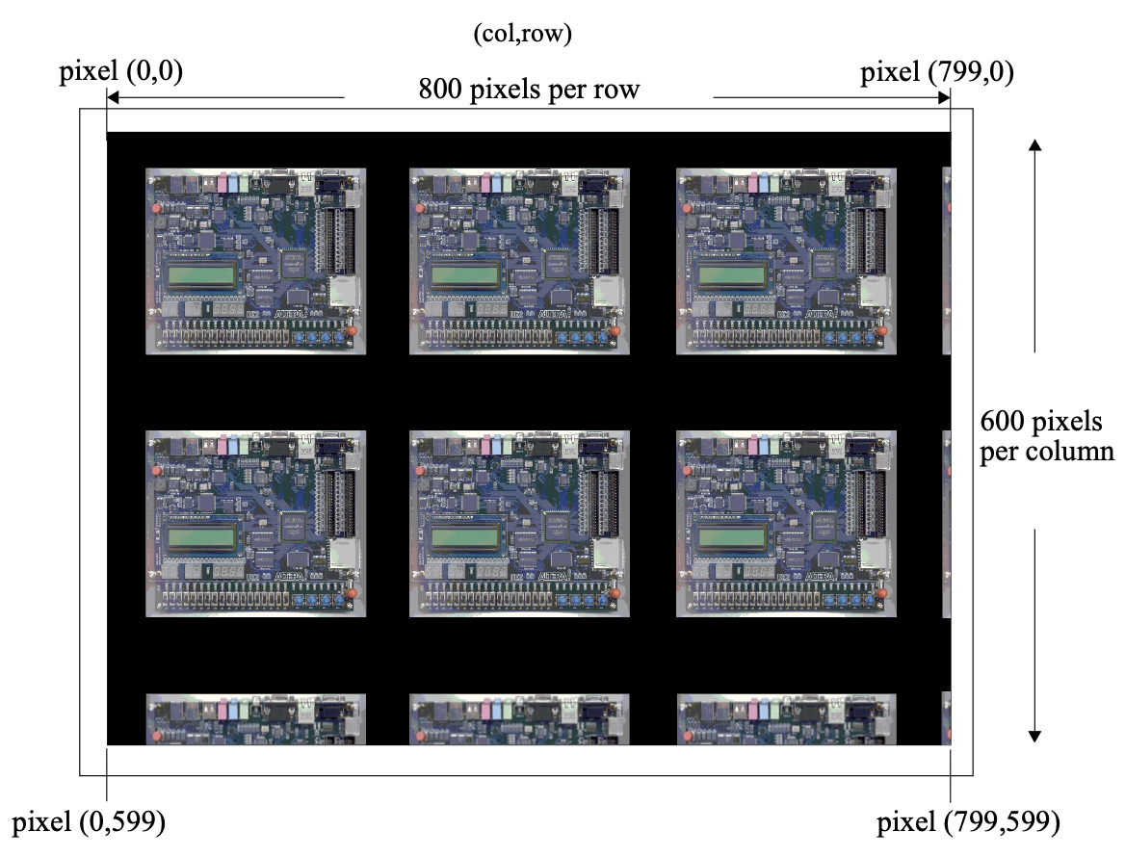

**Figure 5.** DE2-115 Image Display

The expected result of this part of the lab is shown above in Figure 5 with the image of the DE2-115 displayed multiple times on the screen.

Part 2:

In this experiment part, we will modify the translate module to respond to user input from the DE2-115 board's buttons. We'll expand the module's functionality to support image resizing and rotation based on user commands triggered by pressing the designated buttons (KEY[0] to KEY[3]). Our task will be to implement logic to detect button presses and adjust the image orientation accordingly, including centering and scaling the image as necessary. This part of the assignment builds upon the foundation laid in Part 1 and challenges us to integrate user interaction into the display system effectively. Upon completion, the translate module will facilitate dynamic image manipulation, allowing users to interactively control the display orientation on the SVGA monitor.

This requires us to complete the translate module, which alters the ordering of the row/column address bus lines that enter the de2_picture module to allow the orientation to be changed. The design will respond to the pressing of KEY[0]-KEY[3] to display different orientations of the image. When the button labeled KEY[1] is pressed a single copy of the image should appear centered on the SVGA monitor in its normal 256 x 256 pixel resolution. Whenever the KEY[0] key is pressed the same image should again appear in the center of the screen but this time it should be twice its normal size. Whenever the DE2-115 KEY[2] is pressed a centered image should appear. This image should be rotated 90 degrees counter-clockwise. Finally whenever the KEY[3] button is pressed on the DE2-115 the same image should appear in normal resolution and centered but upside down (rotated 180 degrees). These expected results are shown in Figure 6 below.

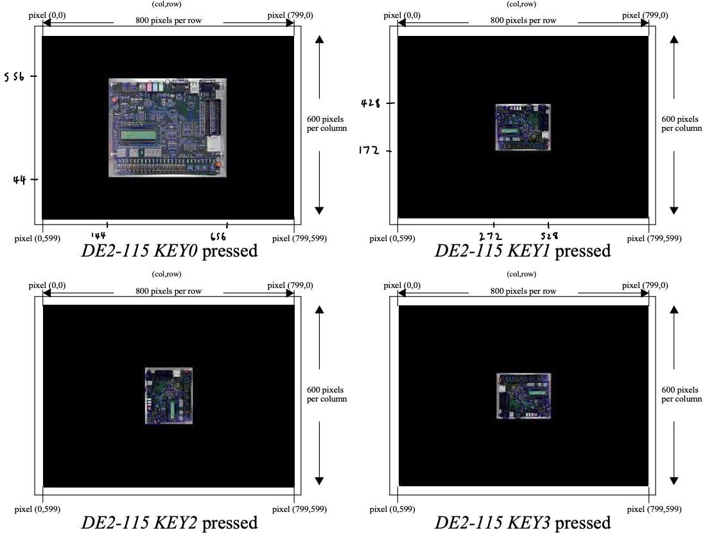

**Figure 6.** DE2-115 Image Translations

1. Demonstration

Part 1:

In this part, we calculated and filled in the appropriate count values to handle the SVGA display refreshes in the svga_sync module based on the horizontal and vertical refresh cycles. Code shown in Figure 7.

The counts could be calculated by multiplying the time by the frequency, so for the max column count to reset the horizontal column counter: 26.4(40) = 1056.

Negative going horizontal synchronization pulse:

col_count >= 800 + 1(40) = 840

col_count <= 800 + (3.2 + 1)(40) = 968

Reset or increment vertical row counter:

row_count == 16.6/26.4 = 631 or col_count == 1056

Negative going vertical synchronization pulse:

row_count >= 600 + 39/26.4 = 601

row_count <= 600 + (39+118)/26.4 = 606

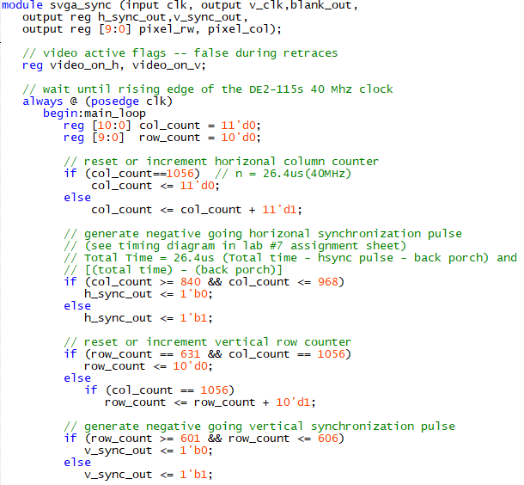

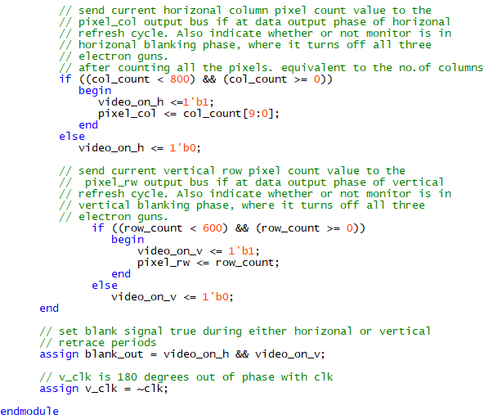

**Figure 7.** svga_sync module

Part 2:

In this part, we altered the case statements for the video mode to display the appropriate version of the image on the display based on what key is pressed. Code is displayed in Figure 8. Calculations are explained below the figure.

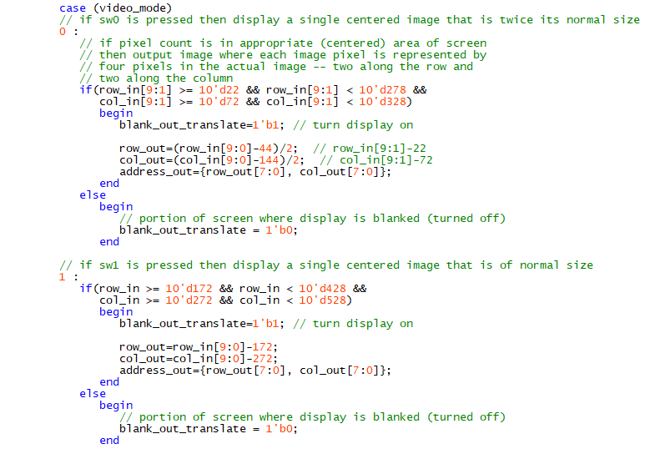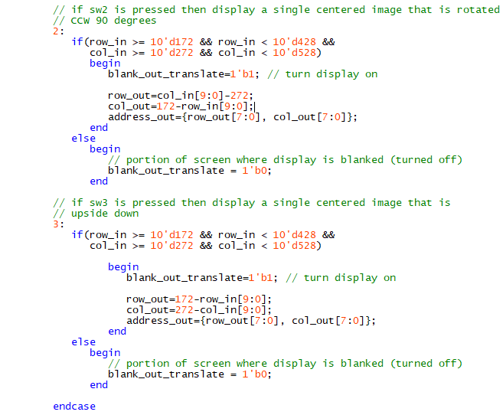

**Figure 8.** translate module case statement

KEY0:

Since we are using [9:1], the threshold values must be divided by 2.

row_count >= ((600-512)/2)/2 = 22

row_count <= (600-44)/2 = 278

col_count >= ((800-512)/2)/2 = 72

col_count <= (800-144)/2 = 328

KEY1:

row_count >= (600-256)/2 = 172

row_count <= 600-172 = 428

col_count >= (800-256)/2 = 272

col_count <= 800-272 = 528

KEY2:

swap row_out and column_out and invert column_out

KEY3:

invert row_out and column_out

1. Experimental Results

Part 1:

We successfully completed the svga_sync module so that it implemented the required timing functionality to drive the SVGA display in a manner that displayed the image of the DE2-115 multiple times on the screen. The result is shown in Figure 9.

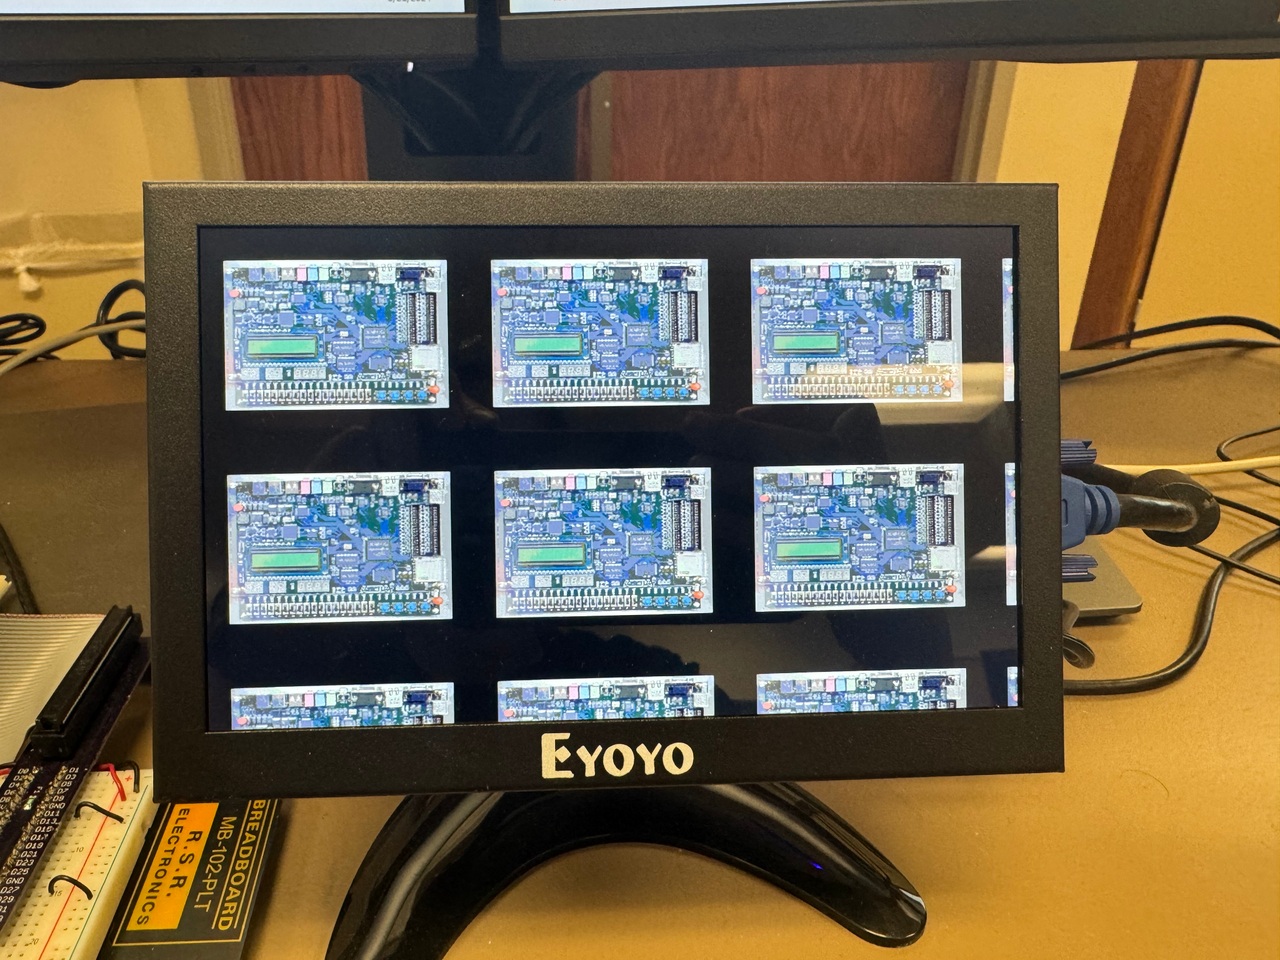

**Figure 9.** Multi-image display

Part 2:

After completing the svga_sync module, we were able to modify the translate module to respond to the KEY[0]-KEY[3] buttons to produce various orientations of the image on the display. The results are shown in Figures 10 through 12, fully demonstrating the functionality of our design.

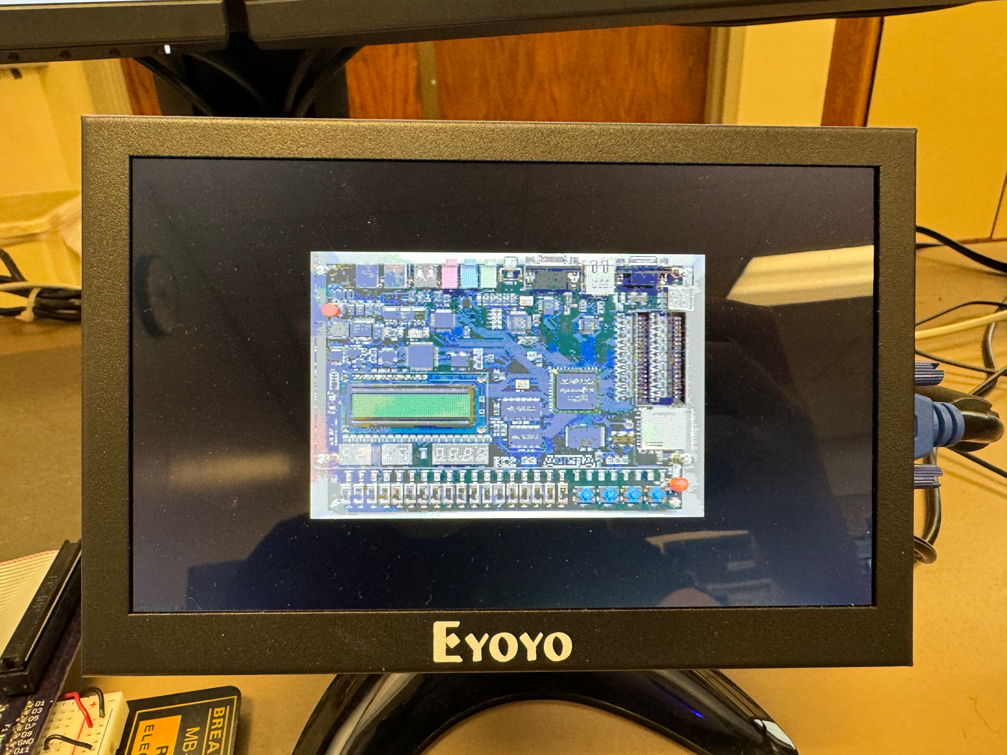

**Figure 10.** KEY0 double size image

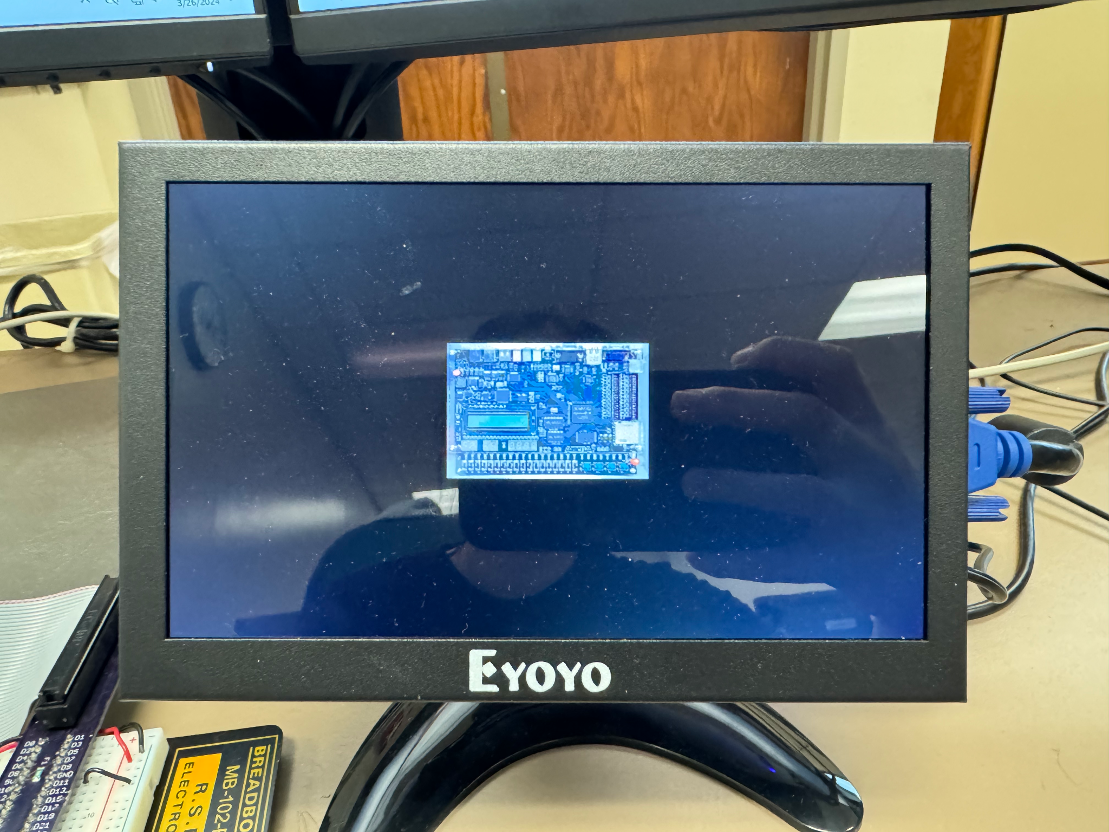

**Figure 11.** KEY1 standard size image

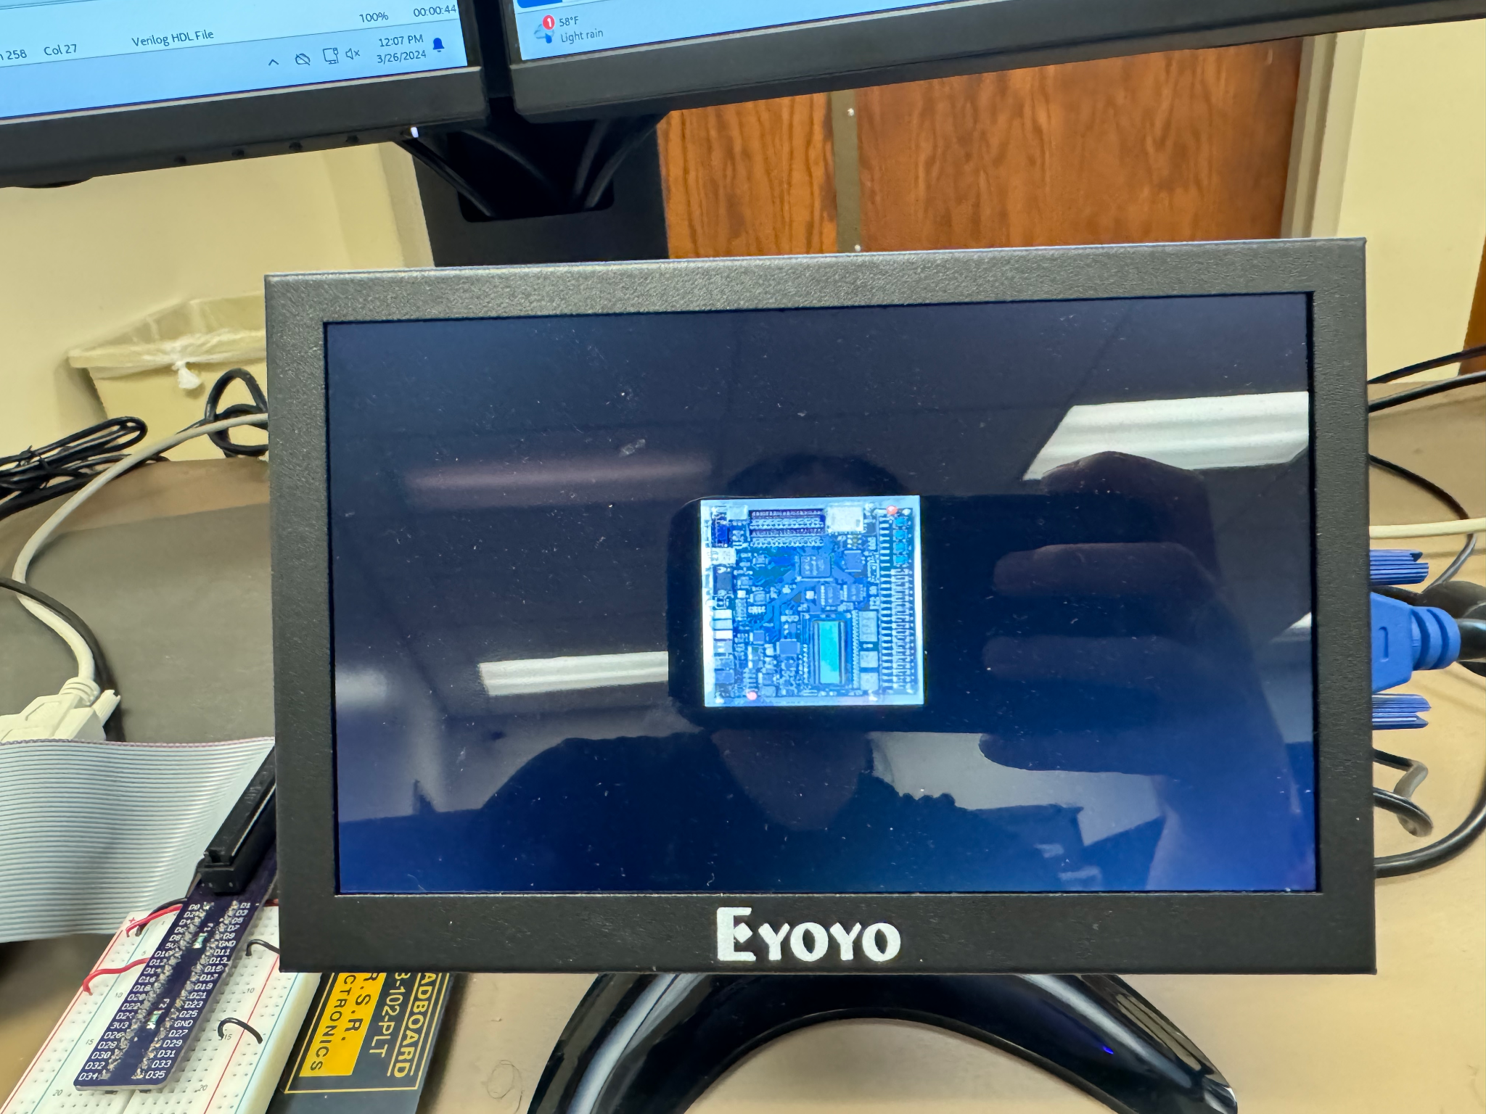

**Figure 11.** KEY2 rotated 90 degrees counterclockwise

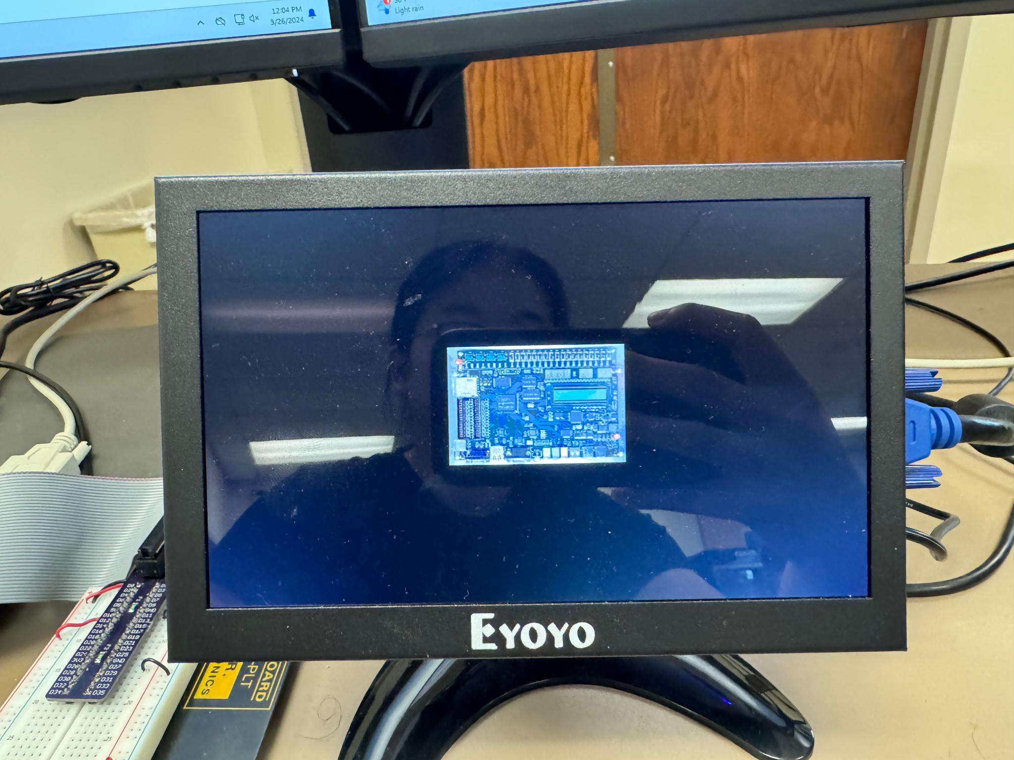

**Figure 12.** KEY3 upside down

Questions

1. What kind of compilation errors or warnings did you encounter? How did you correct the errors and how did you determine which warnings could be ignored?

A compilation error would occur when proper begin and end statements were not used, but no significant warnings were encountered other than that unless the values were not filled properly. Warnings that could be ignored were those that did not affect the functionality of our design, resulting in successful compilation and running of the program.

1. Explain briefly how a phase-lock-loop can be used to multiply and divide external clock frequencies that are used to drive logic within an FPGA such as the Cyclone IV E.

A phase-lock-loop can be used to multiply and divide external clock frequencies by adjusting the control voltage to the voltage controlled oscillator on the phase difference between the input and feedback signals. Then, the phase-lock-loop locks the output frequency to a multiple or fraction of the input frequency. The phase detector compares the phase of the input clock signal with the phase of a feedback signal from a voltage controlled oscillator, and the feedback divider divides the output of the voltage controlled oscillator to produce a feedback signal that is compared with the input clock signal.

1. What is the purpose of the pll_clk_50_to_40 IP core module that was incorporated in the design? Is it possible to generate a 40 Mhz clock signal from a 50 Mhz one that is present on the DE2-115? Could you create a 40 Mhz clock from a 27 Mhz clock if this clock speed was available on the DE2-115 board instead of the 50 Mhz clock? If so, explain how you would do this. If not, explain why this is not possible.

The purpose of the pll_clk_50_to_40 IP core module is to multiply the input clock frequency of 50 MHz to produce an output clock frequency of 40 MHz. This is possible on the DE2-115. It may be possible to create a 40 MHz clock from a 27 MHz clock by generating a higher frequency and then dividing it down, but it is more challenging since it does not have convenient common factors.

1. What is the purpose and function of the de2_picture IP core module? From the reports generated by the Quartus compilation/synthesis/map/place/route process what are the type and number of FPGA internal resources that were used for this module? For the memory element(s) that were employed in the module did Quartus treat them as a combinational ROM type element or as a synchronous Block ROM? Explain your answer?

The purpose of the de2_picture IP core module is to store a 256 color bitmap representing the DE2_115 image ROM. The upper 8 bits represent the row address and the lower 8 bits represent the column address. Data from a text file is read from memory using a directive, with each output value representing the color value 0 to 255 at each pixel location. The data is loaded into a data structure of 65536 elements of 8-bit registers. FPGA internal resources used for this module would likely be treated as a synchronous Block ROM because they are used to store and retrieve data synchronously with the clock signal.

1. What is the purpose and function of the color_palette IP core module? From the reports generated by the compilation/synthesis/map/place/route process what are the type and number of FPGA internal resources that were used for this module? For the memory element(s) that were employed in the module did Quartus treat them as a combinational ROM type element or as a synchronous Block ROM? Explain your answer?

The purpose of the color_palette IP core module is to convert 8-bit color values to the corresponding RGB intensity values for driving a VGA monitor. The three color palettes are characterized by 256 elements of 8 bits each to describe the possible colors of variable intensity. These arrays are implemented using combinational ROM as indicated by the output color values being changed whenever the input color is altered not based on the clock signal.

1. Conclusion

Through the completion of this lab, we gained a comprehensive understanding of computer display technology, particularly focusing on driving an SVGA display on the DE2-115 board. By designing and implementing modules for synchronization, pixel translation, and color handling, we successfully achieved the goal of displaying a 256-color, 256x256 pixel image of the DE2-115 board on the SVGA screen. Moreover, the integration of user interaction through button inputs enabled dynamic image manipulation, including resizing and rotation, adding a layer of interactivity to the display system. Overall, this experiment provided valuable hands-on experience in advanced logic design, reinforcing fundamental concepts while exploring practical applications in display technology.